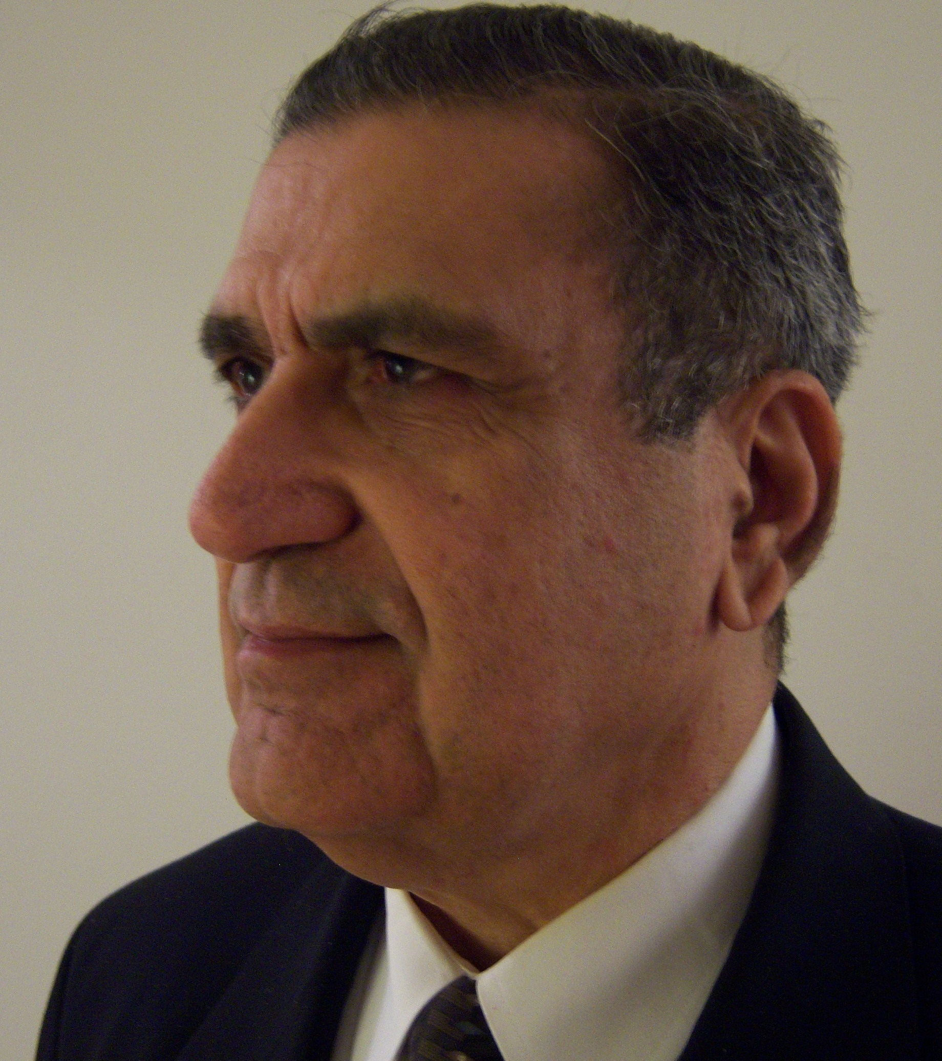 | ViJay K Chopra  Structure Technology Consultant, Entrepreneur  82 School St., Piscataway, NJ 08854  GrandRehabber@GMail.Com Ph: 908 200 2020

SERVICES

- Construction consulting and management, Estimating, Rehabbing, Expert witness, Code Interpretation, Arbitration, Home Inspection for Single / Multi-Family, Commercial etc
- Software development

EDUCATION

1973 - 1975 State University of New York – MS Management
1963 - 1967 Marine Engineering College – BE Marine Mechanical Engineering

MAJOR PROJECTS HANDLED AS OWNER REPRESENTATIVE CONSTRUCTION MANAGER

A. Jain Center of NJ, Franklin Township, NJ - 2007 - $ 10 Million project , 5,000 Sq Ft Religious building on 10 Acres. Owners supervisor for trustees

B. Manufacturing upgrading facility - 40,000 sq feet for Halo Pharma, (Previously Abbott laboratories), Whippany, NJ - 2007. Work included addition alterations in the structure, epoxy floor finishes, and humidity controlled HVAC systems

C. Luxury Condominiums at Morris Street Jersey City on Water Front valuing $11M (Freelanced Construction Consulting to Parmar Group)

D. 2006 - 2007 Project Manager for New Motel on Pile foundation, steel Structure, steel decks, concrete floors at Seaside Heights New Jersey.

E. 1994 to 1997 (Freelanced Project Management) for 27000 sq feet, three levels building with reinforced concrete walls under ground parking & partially for HVAC equipment, chillers, boilers, humidity controls for FDA approved GMP facility in Morris County.

F. 1991-1993 New plans for 52,000 sq feet of head office Foundations only.
Project Manager for, Development of 55,000 sq feet of Existing Warehouse with addition of 15,000 sq feet of Mezzanine floor designed to take 300 lbs per sq feet dead load.
Scope: Freight elevators, loading docks, sales offices, packaging lines, for Pharma Industry.

G. 1987 to 1989 Construction of 6 story condominium at 226 River Road, Hackensack, NJ
The project consisted of pile foundation in sandy soil next to river, pile caps with reinforced concrete plinth beams, steel structure, concrete ramps for 42 car parking on two floors and 7 units on each floor with elevator, grand foyer, state of art finishing with marble floors, walls etc.
Client: River Park Plaza Associates Project Duration 2 years Value of project 5.5 Million

LUXURY HOMES BUILT AS GENERAL CONTRACTOR

290 Mount Harmony Rd., Bernardsville, NJ 07924 - 1985 - For Mr. Sushil, Vandana Manchanda
107 Green St., Woodbridge, NJ 07095 - 1987 - For Dr & Mrs Andrew Rajapakse

REHAB

1638 West 3rd St., Piscataway, NJ 08854 - 1988 - Investor Vijay K Chopra
208 Rock Ave., Piscataway, NJ 08854 - 1989 - Investor Vijay K Chopra
46 Bennetts Lane, Somerset, NJ 08873 - 2015 - Investor Mr. & Mrs Kishore & Dimple Kashyap
18 Cottrell Rd., Matawan NJ 07747 - 2016 - Investor Vijay K Chopra LLC - Current project

EXPERIENCE

2015 - Present Principal Vijay K Chopra LLC Rehabbing Enterprise

2015 - Present Principal Accutech Services LLC Inspections, Construction manager

2007 - Present Principal Incuber Services Produced portals like www.Webbry.com; www.Pnapna.com; www.Incutime.com and many more software applications in a start up worth several million dollars. Re-entered Real estate, Construction and inspections due to markets improved in Real Estate. This enterprise is employee managed and is in simultaneous operation with Real estate, Engineering consultations.

1998-2007 Project Manager SH Construction Inc, 19 Amelia St, Caldwell, NJ 07006. See projects in list above. Moved into software due to several downturn in Real Estate markets.

1994 – 1998 Purchasing Manager, Wallington P&H Supply Co., Inc. A multi-branch, medium size, service & distribution group engaged in Industrial Sales & Maintenance Service. Integrated core in MRO, Plumbing, PVF, Sewer, HVAC & Industrial Sales & Service. Started as outside salesman, promoted to National Sales Manager to PM, responsible for $10M portfolio. Then moved back to construction project management.

1986-1994 Project Manager SH Construction Inc, 19 Amelia St, Caldwell, NJ 07006. Project Manager. Met accident and moved to inside position.

1983-1986 Partner, Abodemaster Corp., a Diversified General & Mechanical Contracting & Real estate Holding Co. Started as an estimator, for institutional, commercial and residential new and rehab construction and progressed to Project Manager responsible for entire profitability of the mechanical & civil construction projects. Venture closed due to sharp downturn in real-estate markets.

1975-1983 Started as Chartering Manager at Oracle Shipping, and progressed to Manager Marine Transport, ICC, Lexington, KY, subsidiary of Oxy Petroleum a fortune-25 Co in oil, coal, mining, distribution and transport company.

1967-1972 Started as Maintenance Marine Engineer, on board international merchant marine ships and progressed to technical superintendent.

GENERAL

USA Citizen. Licensed Marine Mechanical Engineer, NJ State DEP Radon License # MET10975 NJ State Home Inspector License # 24G100021600 HUD Certification # M7807
American Society Home Inspector®#203133, EPA HVAC REF. # 5493135301224
Life member Society of Indian American Engineers and Architects

